Ideation Phase
Empathize & Discover

Date | 11 february2026
Team ID | LTVIP2026TMIDS67435
Project Name | Weather-Based Prediction Of Wind Turbine Energy Output:  A Next-Generation Approach To Renewable Energy Management
Maximum Marks | 4 Marks

Empathy Map Canvas:
Understand the needs, thinking, work challenges, feelings, pains, and gains of stakeholders involved in wind energy production and management.

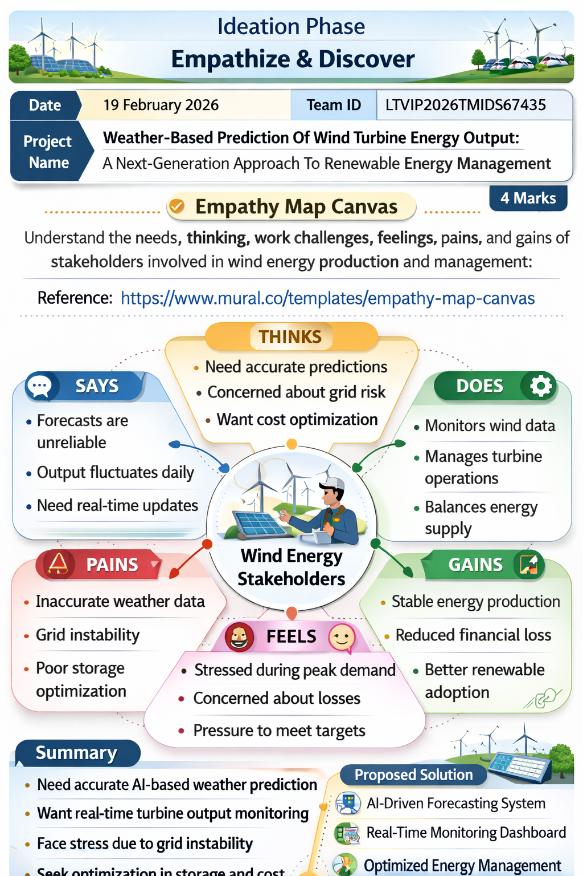

Reference: https://www.mural.co/templates/empathy-map-canvas

